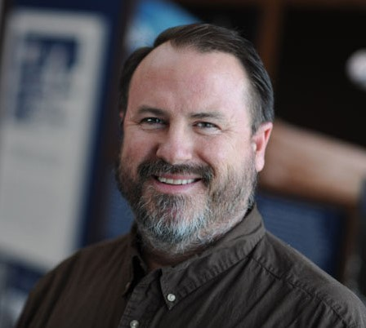
The Muscogee Genealogical Society Presents

Peter Roberts on
“Genes in Your Genealogy:
Using the Science of DNA in
Your Family Tree”
Saturday, August 29, 9am – 1pm
St. Peters United Methodist Church

This half-day seminar will help you learn to differentiate between the various DNA tests and learn how to use them to find and verify your ancestry. Atlanta genealogist Peter J. Roberts will begin his talk with the basic biology of Y-DNA, mtDNA, atDNA and the x-chromosome. He will then present the basics of how DNA testing for genealogy works and explain how you can use the results of your DNA tests to support family history, break through brick walls, and confirm or refute paternal, maternal, and indirect line ancestry.
Peter J. Roberts is an associate professor and archivist at Georgia State University. He has a B.A. in art history from Emory University and an M.A.T. in museum education from The George Washington University.
Peter has been an avid genealogist for about 40 years, first becoming interested in family history in the 1970s when his mother shared with him her father's collection of family stories, charts and photographs of descendants of their 18th Century ancestor, German immigrant John Dekle. He then became curious about his father's ancestry from the Bahamas and was able to interview his paternal Aunt Louise shortly before she died in 1978. When he learned from her that their Roberts line was totally unrelated to other Roberts families in the Bahamas, where that surname is quite common, he was both surprised and skeptical. But in 2004, he was able to confirm through Y-DNA testing that his aunt had been correct about the different lines. In the eleven years since that discovery, he has continued to explore genetic genealogy with a passion.
Peter is an active member of WikiTree, an online community of genealogists on a mission to connect the human family on a free and accurate site using both traditional genealogical resources and DNA testing. Since July of 2013, he has been designing ways to help WikiTree integrate the DNA results of its members. He is currently the administrator for the Bahamas DNA Project and three surname DNA projects: Roberts, Sasser, and Rustin. He is actively researching the Bahamas, Bermuda, Georgia, North Carolina, and Virginia. Peter is a past regional coordinator for the Atlanta area for the International Society of Genetic Genealogy and is a life member of the Clan Donnachaidh Society. He has been recognized by FamilyTree DNA as a Genetic Genealogy Pioneer.

Seminar held Saturday August 29, 2015 at: St. Peters United Methodist Church
Registration 8:30 AM; Seminar 9:00AM - 1PM 6507 Moon Road
Call 706-322-3175 for more information Columbus, GA 31909
Refreshments will be served

Please mail the bottom of this form, with your check for $10.00, payable to Muscogee Genealogical Society, to the Muscogee Genealogical Society, P.O. Box 761, Columbus, GA 31902.

Name_______________________________________________________________________________ Address_____________________________________________________________________________
Phone_______________ email__________________________________________________________

Forms/checks must be received by August 26. Admission at the door: $15.

